Rally Control App. Ver 1.4

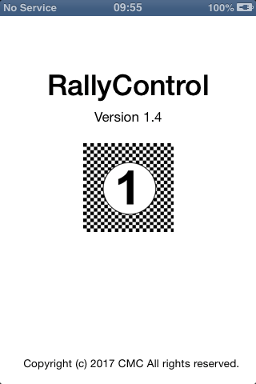

Purpose:
The Rally Control App is used to record times at selected control points and to allocate car numbers to those times.

The main data entry screen.
The main data entry screen is where the user will spend most of the time. The screen changes in appearance depending on the control point which is being monitored but for the majority of control points the screen below is what is on display.

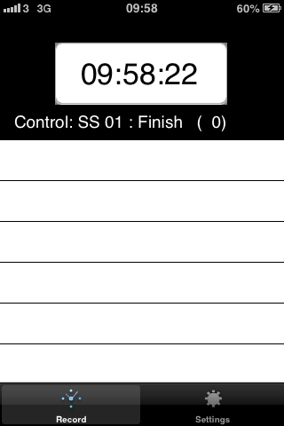

This shows a large clock at the top of the screen which is in the form of a button, a description of the stage and control point being monitored, a list of times recorded (blank in this example), and a selector tab bar at the bottom of the screen to allow you to switch from this screen into the settings screen.

To use this screen (assuming that the correct stage and control have been already selected), you press on the large clock. This will add a new entry onto the list which will appear in the colour RED.
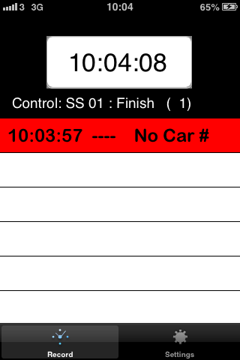

The new entry shows that at 10:03:57 a car passed this control point, but you have not entered the car number yet. If another car comes to the control point before you have entered the car number, you can press the button again, and another entry is added to the list.

To allocate a car number to an entry, tap on that entry. You will now be prompted to enter a car number.
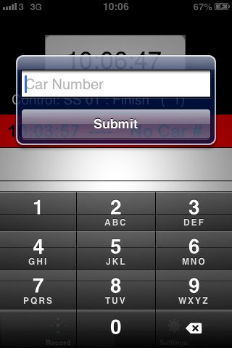
In this example we will press the number 1, and it will convert to 0001 when we press the submit button. If you have selected the wrong entry to add a car number to, just press Submit without entering a car number.

When you have entered a car number and pressed submit, the app will attempt to send this data to the results office. This is indicated by the entry turning to an orange colour.

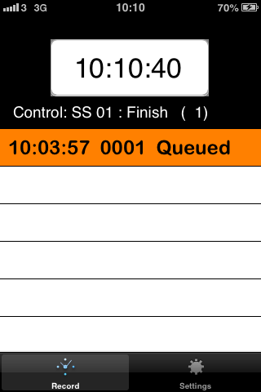

If, for network coverage reasons or for reasons of an issue at the results office the transmission is not successful, you will receive an error message.

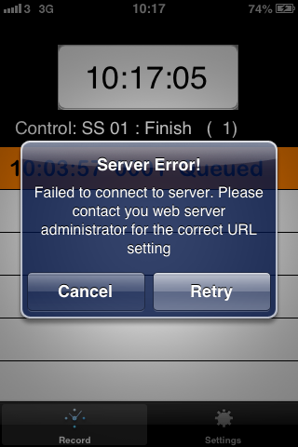

You can opt to retry to send the data or cancel. If you cancel, the entry will remain orange coloured, reminding you that this has not yet gone to the results office. Each time a new entry is added to the list, the send attempt will include all old entries as well as the one just enetered, so if the issue is temporary, the entry will transmit next time you add a car. If this is the last entry and you want to try to send it again, just tap on that entry and press submit again. (You might do this for example, if you move to an area with better mobile coverage).

When the transmission works, the entry will change colour to Green. This indicates that the entry has been transmitted to the server and that the server has received it correctly.

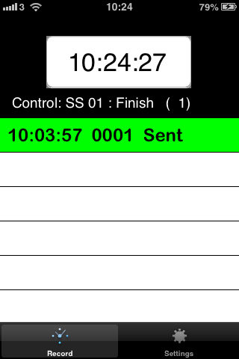

Once an entry has been sent to the server, you can no longer modify that entry. Tapping on that entry will not allow you to change the car number or press the submit button again. If you do send the wrong car number with an entry, you must ring the results office and allow them to change the details on the server. This will not update the entry on your phone, but the correct entry will be on the results system.

Moving to a different control point:

If you need to move to a new control point, you need to tell the app that you are doing so. You need to know the stage number you are moving to, and the name of the control point you are recording.

To tell the app you are changing location, press the settings tab at the bottom of the screen. This will bring you to a new screen. Here you can select the Stage Number and the Control Point. If you change the stage number and/or the control point, you MUST press the SET button afterwards. This is confirming the change and will update the text line which shows which stage and which control point you are recording for.

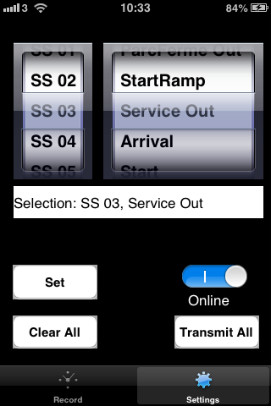

When you do make a change, the App will discard all the times you have recorded up to now. You get a warning to indicate this in case you are making a mistake, or in case you still have some entries which have not yet been sent from the previous control point.

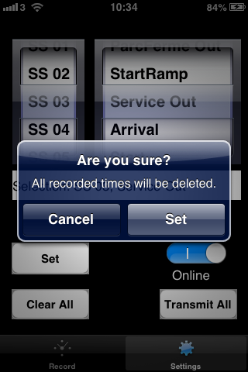

From the settings screen you may also decide to clear out all the readings you have made up to now manually. This should not be neccessary, unless you are using the App for training purposes or unless there are entries still on the App from a previous event.

Finally, the settings screen will allow you to put the App in OffLine mode. This is useful in an area of particularly bad mobile coverage. In this case you are better off collecting the times, allocating the car numbers, but not attempting to send each entry as it happens because of the large number of error messages you will get when the transmissions fail. You can then move to a better reception area, put the App back online and retransmit All the readings at one time. Only use this option if instructed to do so as it does introduce a delay in getting the data to the results office.

Special Case for the Stage Starts.

If you are assigned to the starting line of a stage, then the allocated start times are predefined at regular intervals. So for example it could be that every 30 seconds a car will enter the stage. The App has special logic for the start of a stage. When you select this control point, you will be asked for the start time of the stage (this is the time the first car is expected to enter the stage).

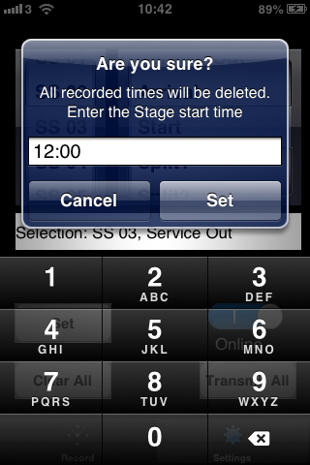

In this example we have set the start time to 12:00. Now when we return to the Record screen (by pressing the tab at the bottom of the screen which is marked Record) you will see that the big clock button is fixed at 12:00:00

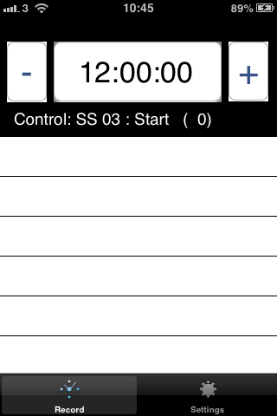

There are some other changes too. On either side of the clock are new buttons showing – and +. The event organiser will have set up the interval between starts so pressing the – will change the clock back by that interval while the + will change the clock forward by that interval. In this case, assuming that the interval is 30 seconds, one press of the + button will change the clock to 12:00:30, and a second press of that button will change the clock to 12:01:00

You will use this button if no car is available to start at a particular starting slot, or if there is an interruption on the stage where cars must be held back.

As before, in order to record a car leaving at 12:00:00, we just just need to press the clock itself. This will add an entry to our list for 12:00:00 and will also move the clock on by one place. (i.e. the next entry will alread show 12:00:30)

When you go to add the car number to an entry in the list, you tap that entry and get a slightly different entry box. Here you are also asked to say whether this car jump started or not.

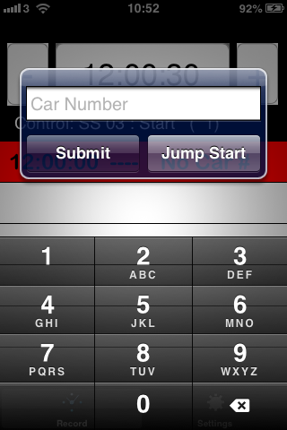

If the car did Jump Start, press that button instead of the Submit button. As in the case with a normal control point, the App will attempt to send the entry once you have entered the car number and pressed one of the buttons. If it is successful, the entry will go green.

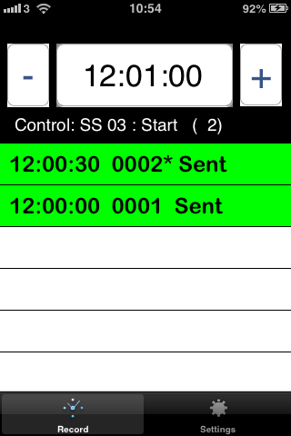

In the two entries shown here, Car 1 was a normal start while Car 2 is recorded as a Jump Start. As before, if an entry goes green, it cannot be changed. If you have entered a car against a time by mistake, ring the results office and inform them so that the results server can be updated.

Setting up the App.

Before an event there is some setup which must be co-ordinated between the App and the results office. This setup is completed in the Setup section of the iPhone under the RallyControl App setup.

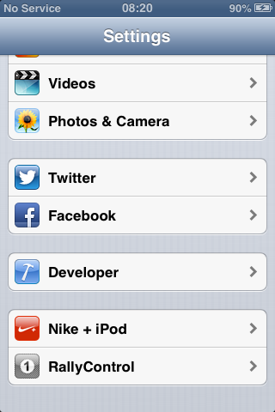

When the RallControl option is chosen here the App setting screen is presented. This screen is presented in several groups. The first group relates to the Server which will collect the data, and the port on which that server can be reached. For the West Cork Rally, these are normally set to 91.142.101.182 and 8081 respectively, while for test purposes, these are set to www.irallyresults.com and 80 respectively.

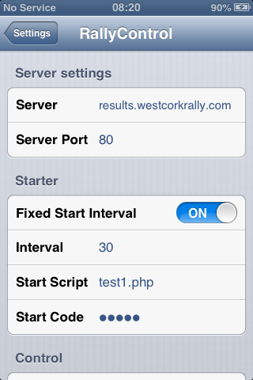

The next section is only required if this iPhone is to be used at the Start of a stage during the rally. Here the option to set a fixed interval or not is set, and then the interval itself is set. In the example above, the fixed interval button is set, and the Interval is set to 30 seconds.

Next a script name must be specified to handle the data when it gets to the server and play the data to the appropriate reader. During a rally, this will normally be set to apps/start1.php and during tests it will be set to apps/starta.php. The start code must be set to a five digit string and must match a string set on the server. This is a security feature to prevent unauthorised iPhones taking part in the event.

As you scroll down the app settings, you will see the rest of the app settings.

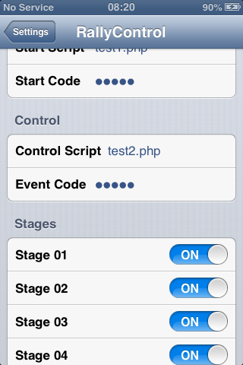

The Control Section of the settings is used only for iPhones which will be used for all control points other than the start or finish of a stage. As in the Start section of the setting program, a script name is required. For the West Cork Rally, this will typically be apps/control1.php and for testing purposes can be set to apps/controla.php.

The event code in this section is not required to be the same as the event code for the Start section (but it could be). This will be decided in advance of the event by the event organiser.

Finally, in the Stages section of the settings program, you select the valid stage numbers for this rally. Typically, stages 1-14 will be used in a two day event. Each stage in the range 1-24 is either selected (ON) or not selected (Off). Selections here will determine the stages which can be selected from within the App itself in the Settings screen.

